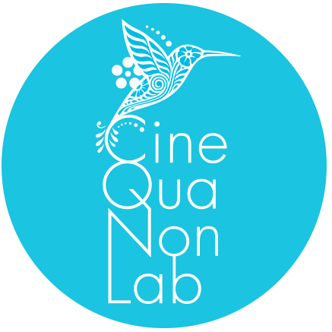 | Cine Qua Non Lab-Estudios Churubusco  Post-production Award  2022

Application Form

PROJECT REPRESENTATIVE (PRODUCER)

Name and surname
Production company
Address
E-mail
Phone

PROJECT

Title of the project
Country(ies)
Director(s)
Writer(s)
Name of the participant in the Cine Qua Non Lab program
Cine Qua Non Lab program [Script Revision Lab or Storylines Lab]
Year of participation

STATUS OF THE PROJECT

Project realization stage [pre-production, shooting, post-production] [If a cut of the movie is already available, please include a link and password]
Total budget [in USD]
Amount of funds secured

By signing below:
(a) I accept the terms and conditions of the call for applicants of the 2022 Cine Qua Non Lab—Estudios Churubusco post-production award.

(b) I attest that all the information contained in this application and the attached materials is true and accurate
Signature of project representative | Date

SUPPORTING MATERIALS
In addition to this application form, please send the following materials:
- Certificate of registration of the script with INDAUTOR — Please submit a copy of the certificate of registration of the script with the Mexican National Institute of Copyright (INDAUTOR), or proof of having started the registration process (complete document).
- Budget — Please submit a detailed budget of the film.
- Secured funds — Please submit proof of secured funds (awards, letters of support from film institutes, etc.).

Please e-mail the completed application form and the supporting materials in separate PDF files to info@cqnl.org. All materials should be received by October 15th, 2022.
In the subject line of your e-mail, please state “Application / Estudios Churubusco Award”.

* * *

