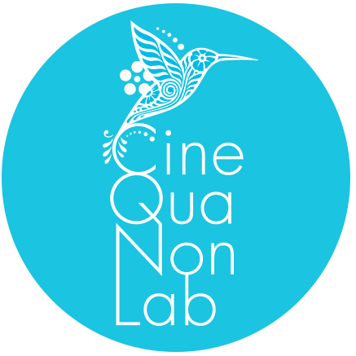 | Cine Qua Non Retreat  Application Form  2025

Name and surname
E-mail
Location [town/city, country]
Citizenship(s) | Date of birth | Gender/Pronouns
Are you a Storylines Lab alum or a Script Revision Lab alum? [What year did you attend? What was the title of your project?]
Are you applying for the Cine Qua Non Retreat with the same project, or are you submitting a new project? [If you are applying with a new project, please tell us about the status of the project(s) you already workshopped with us]
Title of the project you are applying with for the Cine Qua Non Retreat
Logline [A one- or two-sentence description of the story]
Your role on the project [Writer, writer/director, etc.]
Are you applying with a complete script or with a treatment?
Please list anyone else involved in writing the script or treatment
Are you applying with an adaptation of an existing work? If so, why do you want to make this particular adaptation? [In case of projects based on other works, applicants must submit proof that they own the rights to make the adaptation]
Bio [Please tell us a bit about yourself — your personal and professional background, accomplishments, goals, etc.]
Motivation for telling this story [For example: What is the genesis of the project? Why do you want to tell this particular story? What is your personal connection to the story and the project]
Motivation for applying and specific goals you want to achieve during the Cine Qua Non Retreat [Please tell us why you want to attend the retreat, and what are your expectations. Please state the specific goals you want to achieve during your stay]
At what stage of development is your script or treatment? [For example: How long have you been working on the project? Which elements or aspects of the script or the story do you think need more work or further development?]
Participation in other labs, workshops and residencies with this project [Have you participated in other script or project development labs or residencies with this project? If so, please specify which labs or residencies and on what dates]
What is the current status of the project and how do you envision its realization? [For example: What is the estimate budget in USD? Has the project a producer attached? Are there funds already secured? Has the project support from national or international film entities? Is there a cast or art team attached to the project? What is the estimated timeline for the realization of the project?]
Previous work [Please provide links to your previous work online, including passwords if applicable]

Supporting materials
In addition to this application form, please send the following materials:
- A current résumé or CV including your educational background, your work experience and your credits in the film industry
- A synopsis of the story, including the ending (up to 3 pages, using a 12-point Courier font)
- The script in its entirety or an extensive treatment (of at least 15 pages, using a 12-point Courier font)
- A copy of official registration/ownership/copyright of the script or treatment with an appropriate film board or office — i.e. a proper certificate of registration clearly indicating the name of the author(s) and the title of the script or treatment

Please e-mail this application form and the supporting materials in separate files to admissions@cqnl.org. The application deadline is October 20th, 2024. In the subject line of your e-mail, please state “Cine Qua Non Retreat 2025/Your name & surname”.

